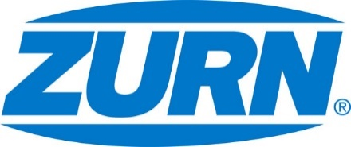

FOR IMMEDIATE RELEASE FOR MORE INFORMATION
DATE: February 13, 2018 Leslie McGowan
Marketing Communications
leslie.mcgowan@zurn.com
814-871-4757

PHOTOS: http://www.lopressroom.com/zurn/scott-mcdowell-vp

Scott McDowell Appointed Vice President, Sales and Marketing
MILWAUKEE, WI – Zurn is pleased to announce that Scott McDowell has been appointed Vice President (VP), Sales and Marketing.

Scott brings deep and broad experience in sales, marketing, business development, and operations. Scott most recently held the role of Vice President, Corporate Rexnord Business System (RBS), where he focused on driving RBS into the commercial organization while continuing its strong deployment across Rexnord global operations. Prior to his role in RBS, Scott held the role of Vice President, Marketing and Business Development for Zurn, where he managed strategic accounts, led the enhancement of innovation and product development, and supported acquisition activity.

Before joining Rexnord in 2011, Scott held roles with Danaher Corporation and Milliken Chemical.

“I am excited to welcome Scott back to the Zurn leadership team,” said Craig Wehr, Zurn President. “His vision for growing the business, passion for customer excellence, and ability to simplify execution will continue to enhance our strategy and performance.”

In his new role, Scott will have responsibility for providing leadership and successful deployment of winning sales strategies, developing effective brand marketing strategies, and the Zurn customer experience. In addition, Scott will be responsible for Zurn businesses in Australia, Canada and the Middle East.

Scott received his Master of Business Administration in General Management and Marketing, as well as a bachelor’s degree in Material Science from Clemson University.

About Zurn Industries
Zurn Industries, LLC is a recognized leader in commercial, municipal, healthcare and industrial markets. Zurn offers the largest breadth of engineered water solutions, including a wide spectrum of sustainable plumbing products. Zurn delivers total building solutions for new construction and retrofit applications that enhance any building’s environment. For more information, visit Zurn.com.
# # #

