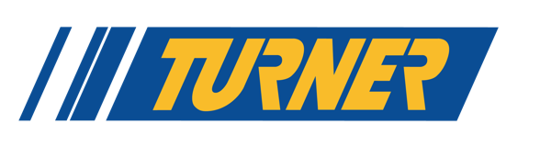
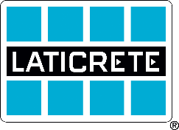

Media Contact:
Samantha Rothberg, (203) 988-6652
strothberg@laticrete.com

LATICRETE & Turner Motorsport Announce Partnership for the 2024 Race Season
The 2024 SRO GT World Challenge kicks-off April 5-7 at Sonoma Raceway

April 10, 2024, Bethany, Conn. – LATICRETE and Turner Motorsport are excited to announce a new partnership for the upcoming 2024 SRO GT World Challenge, with LATICRETE serving as the primary sponsor for the #29 BMW M4 GT3 co-driven by Justin Rothberg and Robby Foley. The flag drops on the eight-race weekend series April 5-7 at Sonoma Raceway in California and concludes October 4-6 at the iconic Indianapolis Motor Speedway 8 hours of Indy race, giving fans and customers high-octane fun from spring through the fall.

Beyond their new venture on the racetrack, LATICRETE and Turner Motorsport share a connection in driver and Ferrari Challenge 2023 North American P-Am Champion Justin Rothberg. His grandparents Lillian Rosenstock and Dr. Henry M. Rothberg founded LATICRETE in 1956 with a commitment to innovation that continues today as a new generation of the family grows into leadership roles at the global manufacturing company.

“Seeing Justin take the track with his family’s company logo on the hood brings a smile to my face,” said Will Turner, Team Principal at Turner Motorsport. “Our team would like to thank Sean Boyle, the Rothberg family, and everyone at LATICRETE for their support this year. We’re hoping to build on a strong 2023 season and continue our rich history of racing success.”

The collaboration is the latest of several LATICRETE partnerships in motorsport, having previously partnered in offshore racing, Sports Car Club of America-sanctioned racing series, local NASCAR series, and more.

“We’re thrilled to be part of this year’s race series with the team at Turner Motorsport, a 9-time championship BMW race team,” said Sean Boyle, Senior Vice President of Marketing & Channels at LATICRETE. “Both LATICRETE and Turner are driven by innovation and have built our legacies on pushing the boundaries of performance and function, so teaming up on the track just makes sense.”

With the season right around the bend, LATICRETE is looking at ways to give its customers a chance to see the car in action.

“Our customers are important to us, and we love finding new ways to celebrate that relationship and enjoy some time together, off the jobsite,” said Samantha Rothberg, Marketing Communications Director at LATICRETE. “It’s going to be an exciting season of racing with Turner Motorsport, and rest assured, we’re working on some creative ideas to get our customers out to the track this season. Stay tuned for more details.”

Fans can see the car in action throughout the season at the following races:
- April 5-7, Sonoma Raceway
- April 19-21, Long Beach Grand Prix
- May 3-5, Sebring International Raceway
- May 17-19, Circuit of the Americas
- July 19-21, Virginia International Raceway
- August 16-18, Road America
- September 6-8, Barber Motorsports Park
- October 4-6, Indianapolis Motor Speedway

More details can be found at www.gt-world-challenge-america.com.

# # #

About LATICRETE
LATICRETE is a leading manufacturer of globally proven construction solutions for the building industry. LATICRETE offers a broad range of products and systems covering tile & stone installation and care, masonry installation and care, resinous and decorative floor finishes, concrete construction chemicals, and concrete restoration and care including the SUPERCAP® System. For over 65 years, LATICRETE has been committed to research and development of innovative installation products, building a reputation for superior quality, performance and customer service. LATICRETE methods, materials, and technology have been field and laboratory proven by Architects, Engineers, Contractors and Owners. Offering an array of low VOC and sustainable products, LATICRETE® products contribute to LEED certification, exceed commercial/residential VOC building requirements, and are backed by the most comprehensive warranties in the industry. For more information, visit laticrete.com.

About TMS
BMW parts specialist Turner Motorsport has been the leading source of high-performance BMW parts and BMW accessories in the USA since 1993. Turner Motorsport offers BMW tuning, BMW performance parts and BMW upgrades for all BMWs, specializing in the BMW M3, M4, M5, M6 and turbo BMW applications such as the 335i. From OEM BMW parts, BMW brake kits, BMW suspension upgrades, BMW performance chips and BMW software to BMW race car fabrication and preparation, Turner Motorsport does it all. www.turnermotorsport.com

