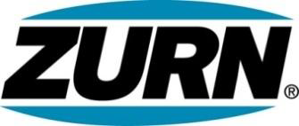

FOR IMMEDIATE RELEASE FOR MORE INFORMATION
DATE: April 30, 2015 Christine Verdecchia
Director of Communications
christine.verdecchia@zurn.com
814-875-1283

PHOTO: http://lopressroom.com/zurn/wear-red

Zurn Associates Promote Heart Health Awareness on “Wear Red Day”

ERIE, PA –Zurn Industries, LLC recently participated in “Wear Red Day” to promote heart health awareness among its associates.

The event was sponsored by the Zurn Associate Council, designed to share community involvement, wellness, and other initiatives across all Zurn facilities.

Wear Red Day promoted these tips for a healthy heart:
• Get Active
• Manage Blood Pressure
• Control Cholesterol
• Eat Better
• Lose Weight
• Stop Smoking
• Reduce Blood Sugar

“Employee health is so important to Zurn says Sheila Scola, Human Resources, Zurn – events such as this offer us the opportunity to provide wellness knowledge, services, and a strong support system.”

Events for the day included presentations from health and fitness representatives and Zurn associates sharing healthy snacks and participating in group walks at lunch.

About Zurn Industries
Zurn Industries, LLC is a recognized leader in commercial, municipal, and industrial markets. Zurn manufactures the largest breadth of engineered water solutions in the industry, including a wide spectrum of sustainable plumbing products. Zurn delivers total building solutions for new construction and retrofit applications that enhance any building’s environment. For more information, visit www.zurn.com.
# # #

