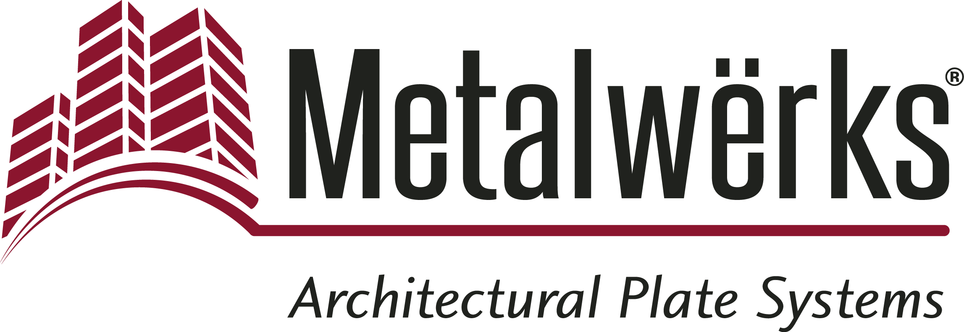

FOR IMMEDIATE RELEASE
Contact: Miriam Lamey, LarsonO’Brien
Phone: 412-831-1959 x136 E-mail: miriam.lamey@larsonobrien.com
Date: June 25, 2019
Photos: http://www.lopressroom.com/metalwerks/sculpted3D_renderings

Metalwërks® Presents High-Definition Sculpted™ 3D Video and
Interactive Renderings
The Sculpted 3D Rainscreen System enables walls to become more than
simply barriers to the elements

KENNETT SQUARE, PA…Metalwërks has launched a new product video and interactive renderings highlighting its most aesthetically-diverse product, Sculpted™ 3D. The visual exploration of this product, available in three different configurations, enables architects, design teams, and others involved in construction and engineering to wholly comprehend its capabilities.

Watch the Video: https://metalwerksusa.com/product/sculpted-3d/

The Sculpted renderings can be zoomed, panned and rotated 360 degrees to explore the material's true aesthetic characteristics. With easily-searchable products and corresponding renderings, users can develop a thorough understanding of Metalwërks’ product offerings, both visually and functionally.

Explore Interactive 3D Renderings: https://metalwerksusa.com/product/sculpted-3d/#design_schemes

“We are excited to present this in-depth look at our Sculpted 3D Rainscreen System, - it’s a great opportunity to show the sheer range of aesthetic possibilities that can be achieved,” says John Scorsone, Sales Engineer, Metalwërks. “Presenting the visual dynamics of this system further enables us to better serve the architectural and design community, allowing them to imagine their designs come to life.”

The all-new, high-definition Sculpted 3D renderings and video can be viewed on any device, whether desktop or mobile.

The Sculpted™ 3D Rainscreen System is a dry-set, solid metal wall panel with three complementary and interchangeable design schemes that produce the boldest three-dimensional forms possible. For more information and to experience the renderings firsthand, visit https://metalwerksusa.com/product/sculpted-3d/#design_schemes

About Metalwërks:
Founded in 1968, Metalwërks is the leading U.S. manufacturer of precision high-performance metal plate exterior facade systems, integrated curtain wall components, and custom architectural features. The company works in close collaboration with top architects to achieve new levels of form and function in systems precision-manufactured from solid metal plate. Metalwërks is unparalleled in the quality, diversity, integrity and reputation of its systems, services, and employees. For more information, visit: www.metalwerksusa.com.

*Patent Pending

# # #

